Report on lab 10. Litvin Saveli

# 2. Oracle Architecture - Parallel execution

## 2.1. Task 01: CREATE Example of Select Parallel execution

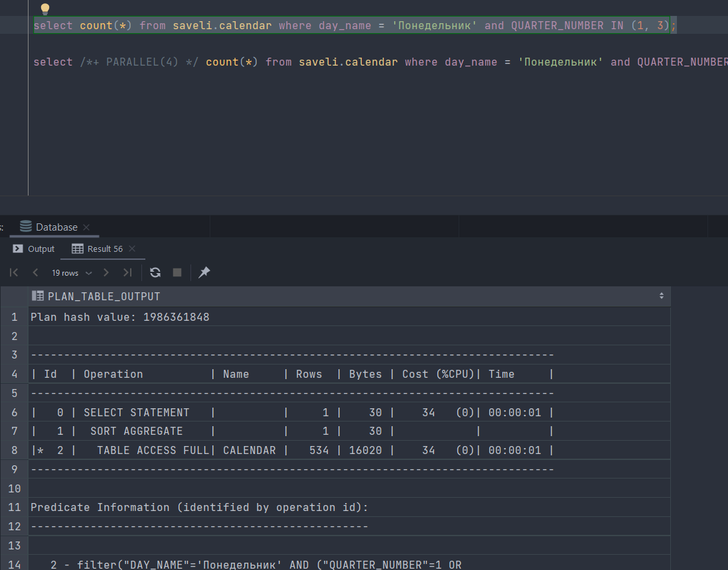

Basic select

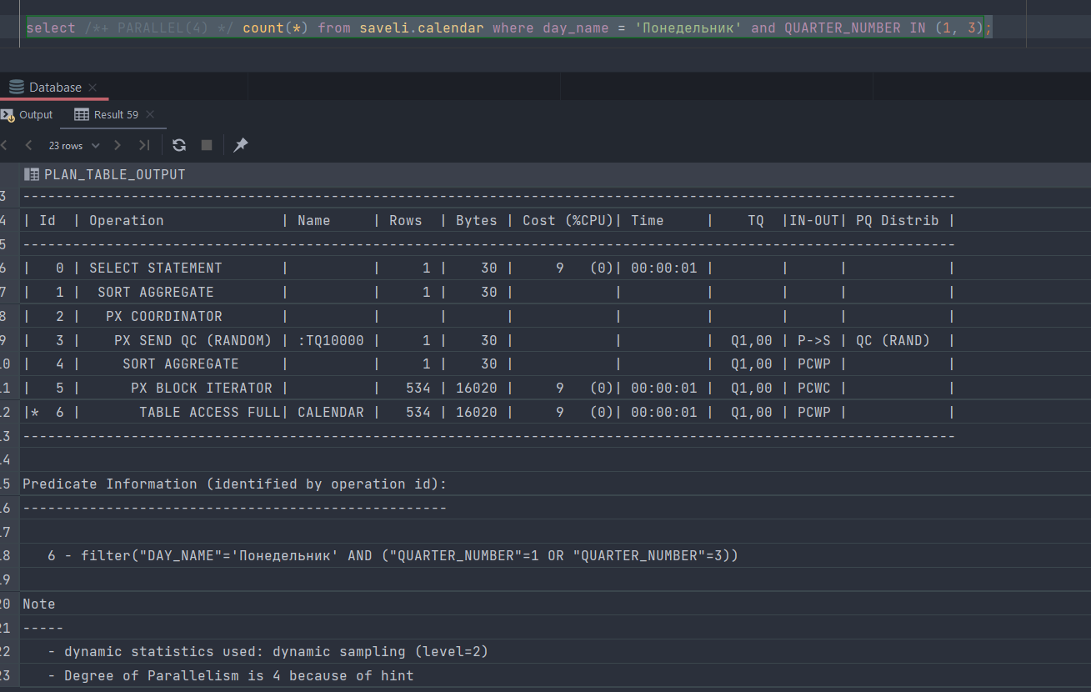

Parallel Select

Time comparing



|  |  |
| --- | --- |
| Basic Select | Parallel Select |
| 47ms | 41ms |

## 2.2. Task 02: CREATE Example of Parallel DML

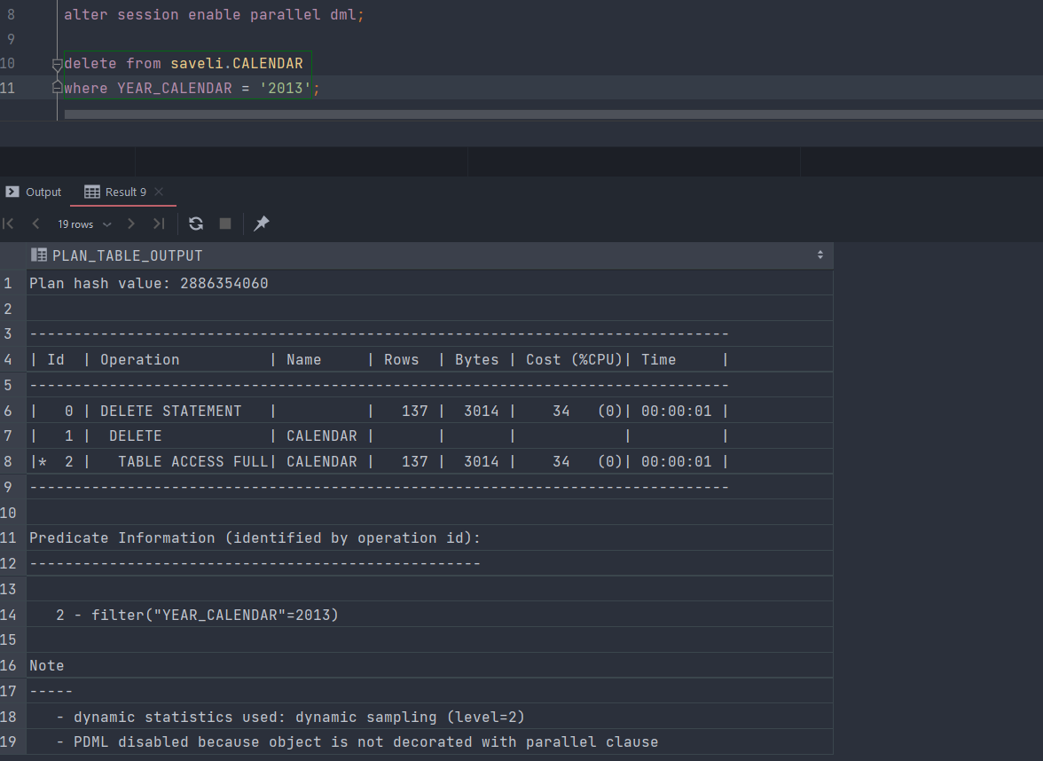

Basic Delete. Execute plan

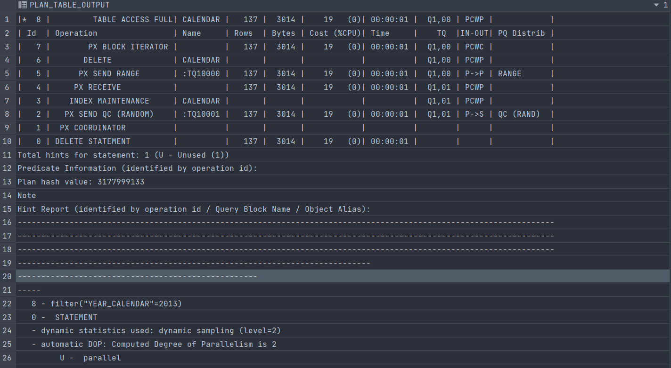

Parallel Delete. Execute plan

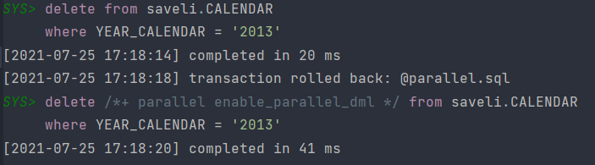

Time Comparing

|  |  |
| --- | --- |
| Basic Delete | Parallel Delete |
| 20ms | 41ms |

## 2.3. Task 03: CREATE Example of Parallel DDL

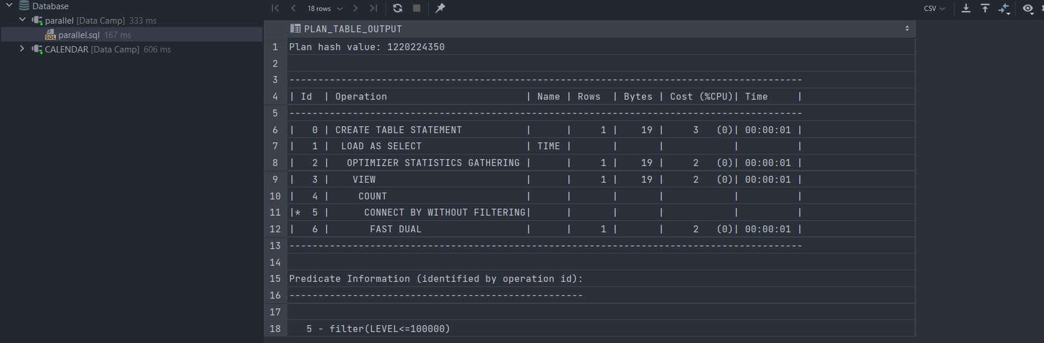

Basic Creation

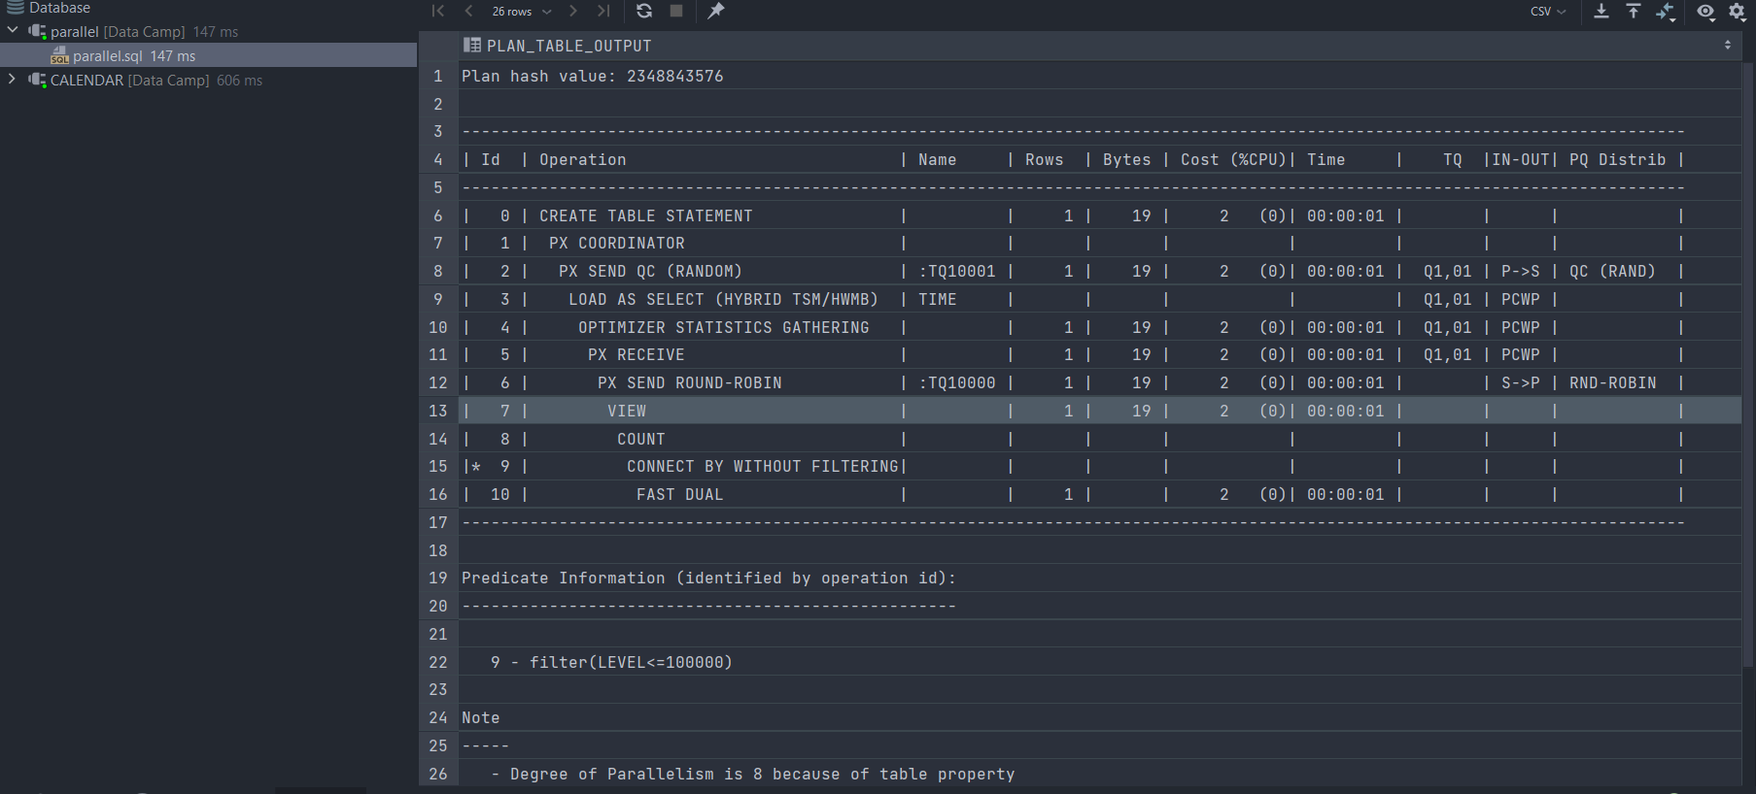

Creation with parallel DDL

Comparation Table

|  |  |
| --- | --- |
| Basic Creation | Creation with parallel DDL (8) |
| 2 s 517 ms | 674 ms |